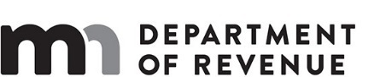

LOCAL SALES AND USE TAX

City of Excelsior

February 25, 2019
 | Yes | No
DOR Administrative Costs/Savings |  | X

Department of Revenue

Analysis of S.F. 41 (Osmek) / H.F. 1130 (Morrison)

The bill authorizes the city of Excelsior to impose a sales and use tax of up to 0.5%, as approved by the voters at the 2014 general election. The proceeds would be used to finance capital and administrative costs of improvements as indicated in the city Commons Master Plan. Authorized expenses would include accessibility improvements, beach area and facilities enhancements, shoreline erosion management, and port and band shell redesign and improvement of playground equipment. The bill authorizes a bond issuance of up to $7 million plus bond costs.

The tax would expire the later of 25 years after it was first imposed or when the city council determines that $7 million plus bond costs has been received from the tax. The tax may expire earlier if the city so determines by ordinance.

The bill would have no impact on state taxes.

Source: Minnesota Department of Revenue
Tax Research Division
www.revenue.state.mn.us/research_stats/Pages/Revenue-Analyses.aspx

sf0041(hf1130)_1 / sd

